Introduction

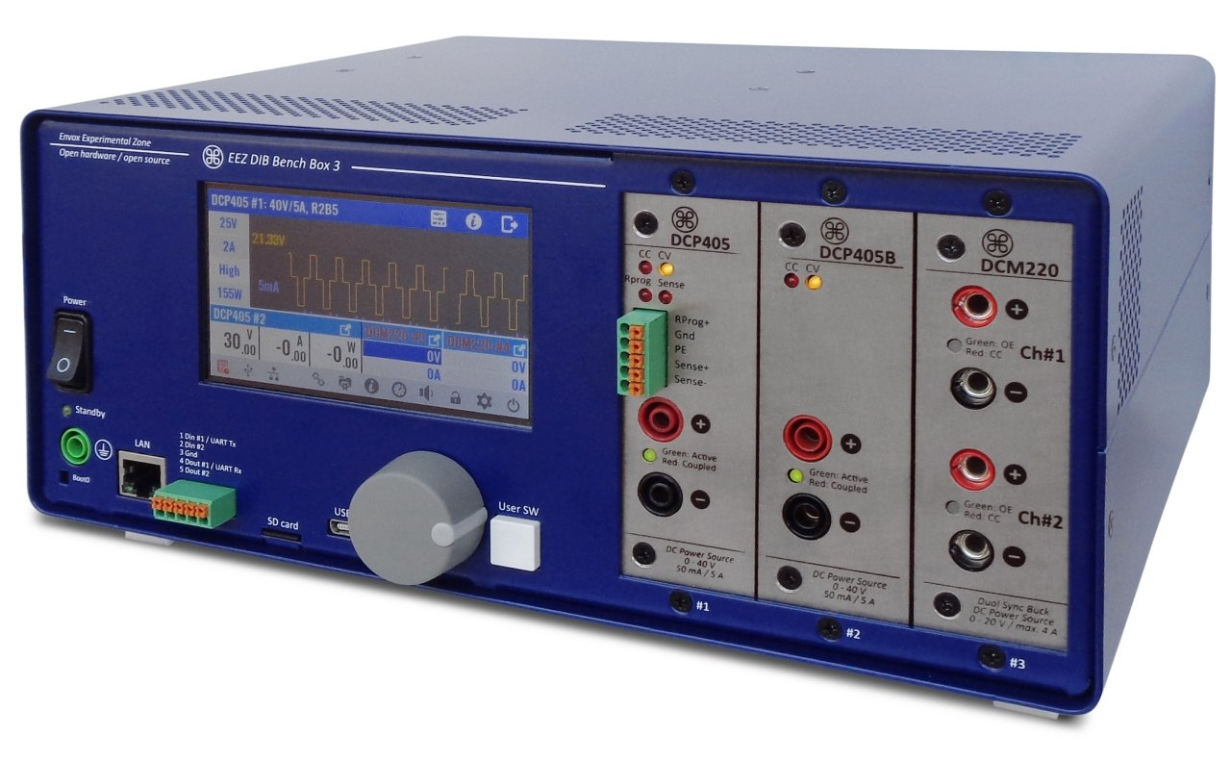Fig. 1: BB3 prototype with various power modules

The EEZ Bench Box 3 (BB3) is the first product based on the EEZ DIB concept. Its aim is to provide a complete software and hardware framework for making a new category of modular test and measurement (T&M) equipment positioned between entry-level/hobbyist/DIY and professional solutions combining their best features. The EEZ DIB was inspired by EEZ H24005 programmable power supply project that already attracted many enthusiasts with its feature set, rich user interface, DIY friendliness and fully open source software and hardware design. Therefore, the first version of the EEZ BB3 is equipped with modules that provide EEZ H24005 functionalities in the first place and offer increased modularity, capacity and processing powers.
The EEZ BB3 continue the practice of design in a manner that it can be easily build by DIYers/makers with intermediate skills in soldering, assembling, testing and have basic understanding of software and firmware installations and uploading. Although it includes custom made enclosure, builder has a freedom to make his/her own enclosure or adopt some general purpose enclosure of similar dimensions.
Additionally, when custom enclosure is selected, one can choose to increase the number of peripheral modules by extending its backplane to some higher number.
Thanks to modular design, the EEZ BB3 based solution can be build gradually in accordance with ones needs and budget. Peripheral modules can have their own processing resources or can be controlled from master MCU that keeps costs low. The EEZ BB3 can be controlled locally (TFT touchscreen, encoder) or remotely (USB, Ethernet).

Quick facts
- Fully open source
- Modular design
- Full range autoswitch AC input (115 / 230 Vac)
- Minimalist wire harness for simplified assembling and servicing
- Up to 3 peripheral modules
- STM32F7 ARM 32-bit MCU
- 4.3” TFT touchscreen display
- Front panel AC power switch
- Front panel bootloader switch for main MCU (firmware upload via USB DFU)
- Incremental encoder and user-defined switch
- USB FS and 10/100 Mbit/s Ethernet connectivity
- Four power relays for various power outputs coupling
- Dedicated full-duplex SPI for each module
- Dedicated bootloader control for each module (firmware upload via UART, SPI or I2C)
- Low noise Ø80 mm cooling fan with speed control
- Remotely controlled by 300+ SCPI commands using the EEZ Studio of similar SCPI controllers, Node-RED, etc.
- MicroPython support
- MQTT support
- Compact size: 290 (W) x 123 (H) x 240 (D) mm
- Weight (populated with 2 x DCP405 and 1 x DCM220): 4.05 kg

Building blocks
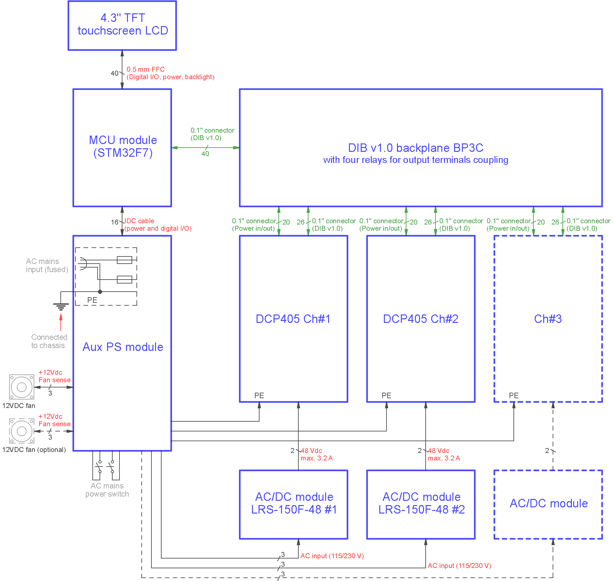Fig. 2: EEZ BB3 block diagram
The EEZ BB3 chassis can accept different type of modules regardless of their functionalities (processing, auxiliary power, programmable power source, backplane, etc.). The number of modules is expecting to grow over time, and the initial version consists of the following modules:
- BP3C backplane
- AUX Power supply
- STM32F7 MCU board with 4.3” TFT touchscreen display
- DCP405 power module (requires +48 Vdc “off-the-shelf” AC/DC power module)
- DCM220 dual output power module (requires +48 Vdc “off-the-shelf” AC/DC power module)
Technical specification of EEZ BB3 that includes above mentioned modules and its comparison with the EEZ H24005 is presented here.

